Table of Contents

Overview 2

Developer Notes 3

MISC 5

# Overview

This document describes the changes made for the **TaskID**#: ITJN028-II-II - c, link -

<http://web.jmgrovebuildingsupply.com/Sr_App/TaskGenerator.aspx?TaskId=398&hstid=424>

Following souce code files are modified and committed GitHub repository :

|  |  |
| --- | --- |
| **Fine Name** | **Path** |
| 1. EditUser.aspx | https://github.com/jmgrove2016/JGProspectLive/blob/nandc/JG_Prospect.web/Sr_App/EditUser.aspx |
| 1. EditUser.aspx.cs | https://github.com/jmgrove2016/JGProspectLive/blob/nandc/JG_Prospect.web/Sr_App/EditUser.aspx.cs |
| 1. InstallUserBLL.cs | https://github.com/jmgrove2016/JGProspectLive/blob/nandc/JG_Prospect.BLL/InstallUserBLL.cs |
| 1. InstallUserDAL.cs | https://github.com/jmgrove2016/JGProspectLive/blob/nandc/ JG_Prospect.DAL/InstallUserDAL.cs |
| 1. ITJN028-II-II - c F&L Name Column Upgrade v1.0.sql | https://github.com/jmgrove2016/JGProspectLive/blob/nandc/Database Scripts/nandc/ ITJN028-II-II - c F&L Name Column Upgrade v1.0.sql |
| ITJN028-II-II - c F&L Name Column Upgrade_05082017.docx.docx | https://github.com/jmgrove2016/JGProspectLive/blob/nandc/ ITJN028-II-II - c F&L Name Column Upgrade_05082017.docx.docx |

The ITJN028-II-II - c F&L Name Column Upgrade v1.0.sql file contains following objects and scripts:

|  |  |
| --- | --- |
| 1. UDP_ChangeDesignition |  |

# Developer Notes

This section lists the assumptions, feedback, questions, issues, changes, testing done etc. for completing this task.

|  |  |
| --- | --- |
|  | Requirement# A1) - Assuming applicant profile page is ViewApplicantUser.aspx |
|  | A) merge existing column Header "First Name" & Last Name" = into column header "ID#";  "Designation", "F&LName A1) upgrade designation field to drop down |
|  | The DropDownList ID="drpDesig" field was already created in GitHub code. Renaming the same to “ddlDesignation” was giving error in Merge/GitHub. So it is left as it is. |

|  |  |
| --- | --- |
|  | **EditUser.aspx**   * There are about 649 records in the users grid. To format all the Status drop-down fields in the grid is taking too long, and the browser is returning timeout message. I tested with 100 records in the grid, and it works fine.   This is existing issue in interview.jmgrovebuildingsupply.com portal: |

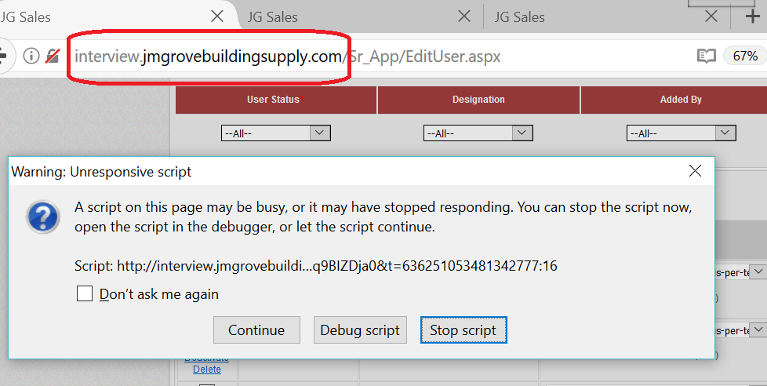

# MISC

Please let me know if you need anything else and I would be happy to work.

**Thank you!**

Nand Chavan